

MOHAMMED FARAG

*IT ENGINEER*

|  |  |  |
| --- | --- | --- |
| mmusa3914@gmail.com | +966543769518 | Riyadh - Saudi Arabia |

**ABOUT ME**

I am a dedicated and customer-oriented IT Support professional with a passion for helping others resolve technical issues. I have a solid foundation in IT systems, hardware, software, and networking. My goal is to ensure that users have a smooth and efficient experience with technology by promptly addressing their concerns and providing effective solutions.With excellent problem-solving skills, I thrive in dynamic and fast-paced environments. I am adept at troubleshooting various technical issues, ranging from hardware malfunctions to software glitches. I have a strong understanding of operating systems, such as Windows and macOS, and I am familiar with common productivity software and tools.

**SKILLS**

**Skills**  
• Technical Troubleshooting: Ability to identify and resolve technical issues related to hardware, ,networks, and systems.

• Experience in MS apps and Outlook and familer with Intune and have good knowledge with ManageEngine MDM applications.

• Database Management like MySQL, PostgreSQL,NoSQL databases like MongoDB.

• Familiarity Cloud Platforms Familiarity with cloud-based data solutions and good knwnledage with Active Directory.

• Networking Concepts Basic understanding of And network monitoring tools and reporting & good understanding in VSAT.

• Experience in providing remote support &desktop support to users & hardware-related issues and Basic IT Service Management Understanding of ITIL.

• Excellent problem-solving and communication skills ,Teamwork , Conflict resolution ,Active listening , Active Learning , Research , willingness to learn new technologies.

**PROFESSIONAL EXPERIENCE**

**System Support Engineer**  07/2023 – present **General Authority for Survey and Geospatial Information**  Riyadh, Saudi Arabia

•Implement system imaging for current & new systems through SCCM & other software.

•Support consist of troubleshooting hardware and software failures at the OS level and providing root cause analysis.

•Install, test, maintain and troubleshot network devices, including routers, switches and firewalls.

•Provide technical assistance for internal teammates on PC issues, configurations and installations for their personal assign laptops.

•Researching, diagnosing, troubleshooting and identifying solutions to resolve system issues

1 / 3

**SUPPORT ENGINEER L2**  09/2022 – 05/2023

**B2BROKER - LIQUIDITY & TECHNOLOGY PROVIDER**  Dubai,

•Work with the products and services of the company and the company’s United Arab Emirates

partners.

•Receive call from service desk, L-1 Tech support & Executive support team.

•Respond to requests and complaints of external clients via communication

instruments (helpdesk, chat, email, etc.) in a timely manner according to the

SLA.

•Check, process and analyze issues incoming from clients.

•Solve issues/incidents/problems independently and /or with help of colleagues.

•Perform monitoring of the company’s services and products via monitoring.

•Co-ordination with vendor, Co-ordinate with offshore and onsite tech support

team.

•Escalate and Coordinate with remote support team offshore to get the user

issues resolved.

•Participate in informal team meetings, client meetings, internal Operations

meetings and Quality review meetings.

•Co-ordination with the other support groups and Domains.

**IT ENGINEER**  02/2021 – 09/2022

**GOVERNMENT OF SHARJAH SHARJAH ARCHAEOLOGY AUTHORITY**  Sharjah,

•Provide Technical Support to Software Users. United Arab Emirates

•Support and enhancements in existing systems and platforms.

•Installing computer hardware configurations. Provide hardware upgrade

services for laptop & desktop.

•Installing software and networking systems. Trouble ticket maintenance and

•Maintain file and print (Location specific).

•Generate and provide weekly, monthly activity and other reports.

•Respond to phone, email, and chat inquiries from customers.

•Provide LAN support (LAN admin support with touch services).

•keep computer systems running smoothly and ensure users get the maximum

benefit from them

**SUPPORT ENGINEER**  10/2019 – 11/2020

**AL JAZEERA SUDANESE JORDANIAN BANK**  Khartoum, Sudan

•Coordinating with development teams to determine application requirements.

•Writing scalable code using Python programming language.

•Installing computer hardware configurations.

•Installing software and networking systems.

•Troubleshooting network and software issues , technical issues.

•Fixing hardware, software, and networking issues.

•Configuring and installing various network devices and services (e.g., routers,

•switches, firewalls)

•Provide Level-1 support and troubleshooting to resolve issues.

•Reporting network status to key stakeholders.

•Resolve issues for staff via phone, in person, or electronically

**IT ASSISTANT**  10/2017 – 10/2019

**MINISTRY OF HIGHER EDUCATION**  Khartoum, Sudan

•Collaborating with other engineers and workers to design, develop, test, and

improve products and

•engineering processes.

•Resolve customer problems on a daily basis both accurately and in a timely

manner

•Assisting the development manager with all aspects of software design and

coding.

•Writing and maintaining code.Writing reports.

•Answering telephones and taking messages.

•Printing and filing documents.Composing emails.

•Typing up reports for the company manager.

2 / 3



•Organizing company travel arrangements.

•Providing technical assistance with equipment operation.

•Cleaning of technical equipment.

**EDUCATION**   
**BSc (Hons) Computer Science & IT**  Khartoum, Sudan **University of science and technology**   
 **LANGUAGES**

|  |  |  |  |
| --- | --- | --- | --- |
|  | Arabic |  | English |

3 / 3

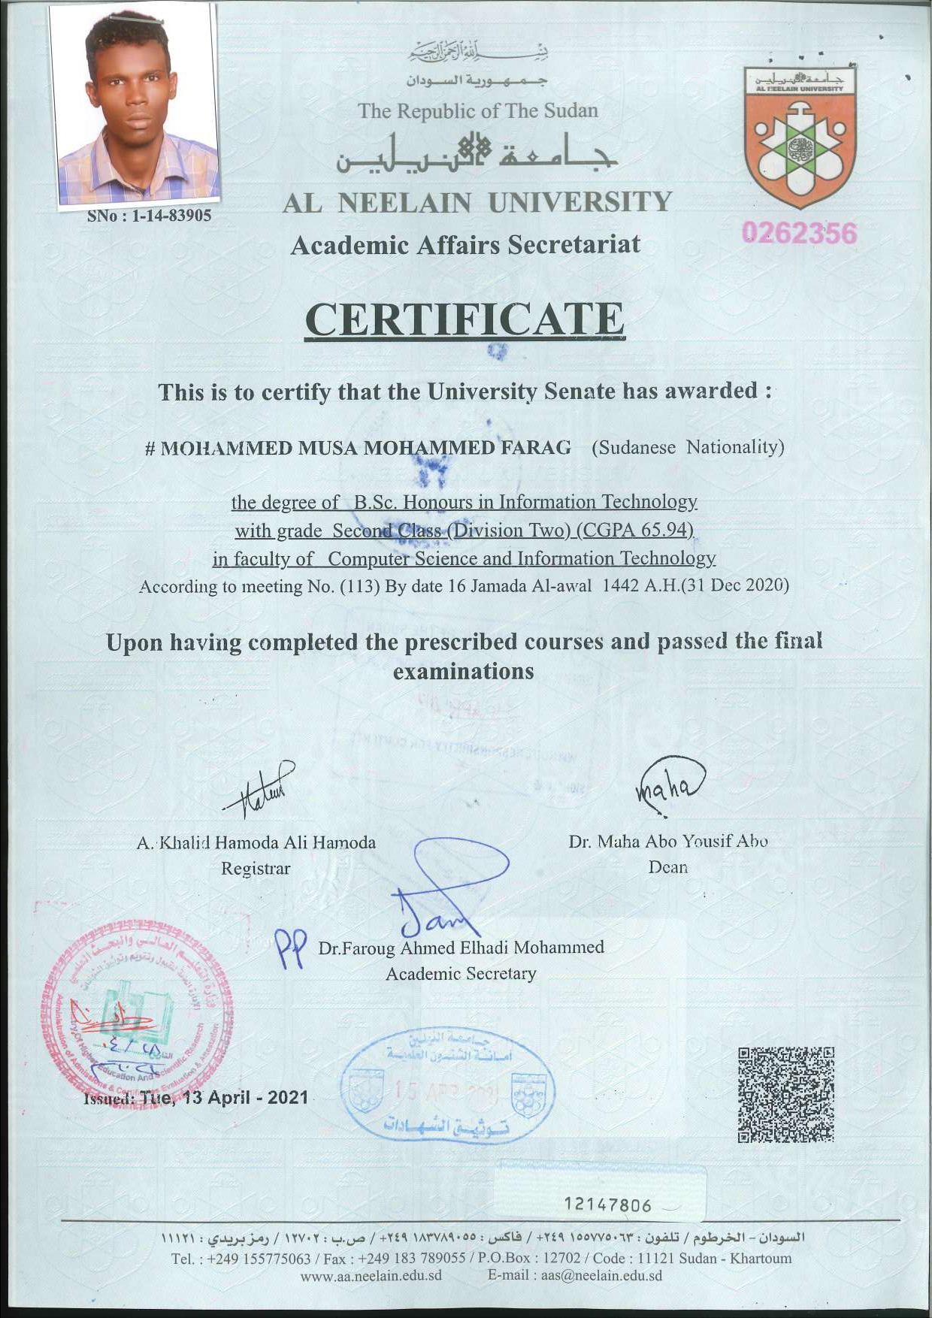



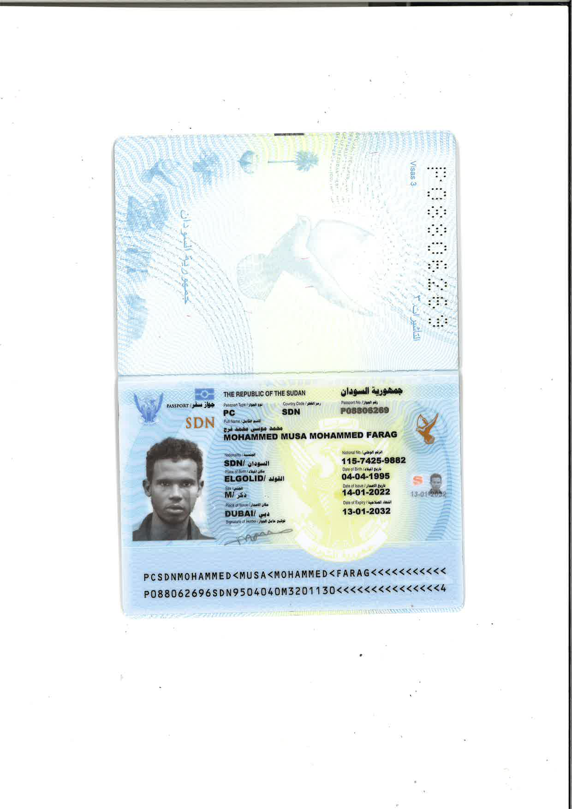

|  |
| --- |
| Dear Admissions ,  I am writing to express my keen interest in enrolling in the Artificial Intelligence and Data Science and Analytics at MTU. My desire to pursue this course is rooted.  I am genuinely passionate about Artificial Intelligence and Data Science and Analytics , and enrolling in this course will provide me with the in-depth knowledge and skills necessary to excel in this area. The curriculum's focus on Artificial Intelligence and Data Science and Analytics aligns perfectly with my academic and professional aspirations.  This course is a pivotal step in achieving my career goals. I am confident that the comprehensive and industry-relevant content will equip me with the expertise required to make meaningful contributions to Artificial Intelligence and Data Science and Analytics.  I am particularly excited about the opportunities for research and innovation that the course offers. The prospect of engaging in Artificial Intelligence and Data Science and Analytics aligns with my interest in contributing to cutting-edge advancements in the field.  My academic background in Artificial Intelligence and Data Science and Analytics provides a solid foundation for this course. I have excelled in Artificial Intelligence and Data Science and Analytics, demonstrating my dedication and aptitude for the subject matter.  Through extensive research on MTU, I am impressed by the institution's commitment to. I am eager to contribute to and thrive within this dynamic academic environment.  In conclusion, enrolling in the Artificial Intelligence and Data Science and Analytics at MTU is a natural progression for me, given my passion for the field, aligned career goals, and the confidence in my ability to contribute meaningfully to the academic community at MTU. I am excited about the prospect of joining your esteemed institution and am confident in my capacity to excel in this course.  Thank you for considering my application. I look forward to the possibility of contributing to the vibrant academic community at MTU.  Sincerely,  Mohammed Farag |

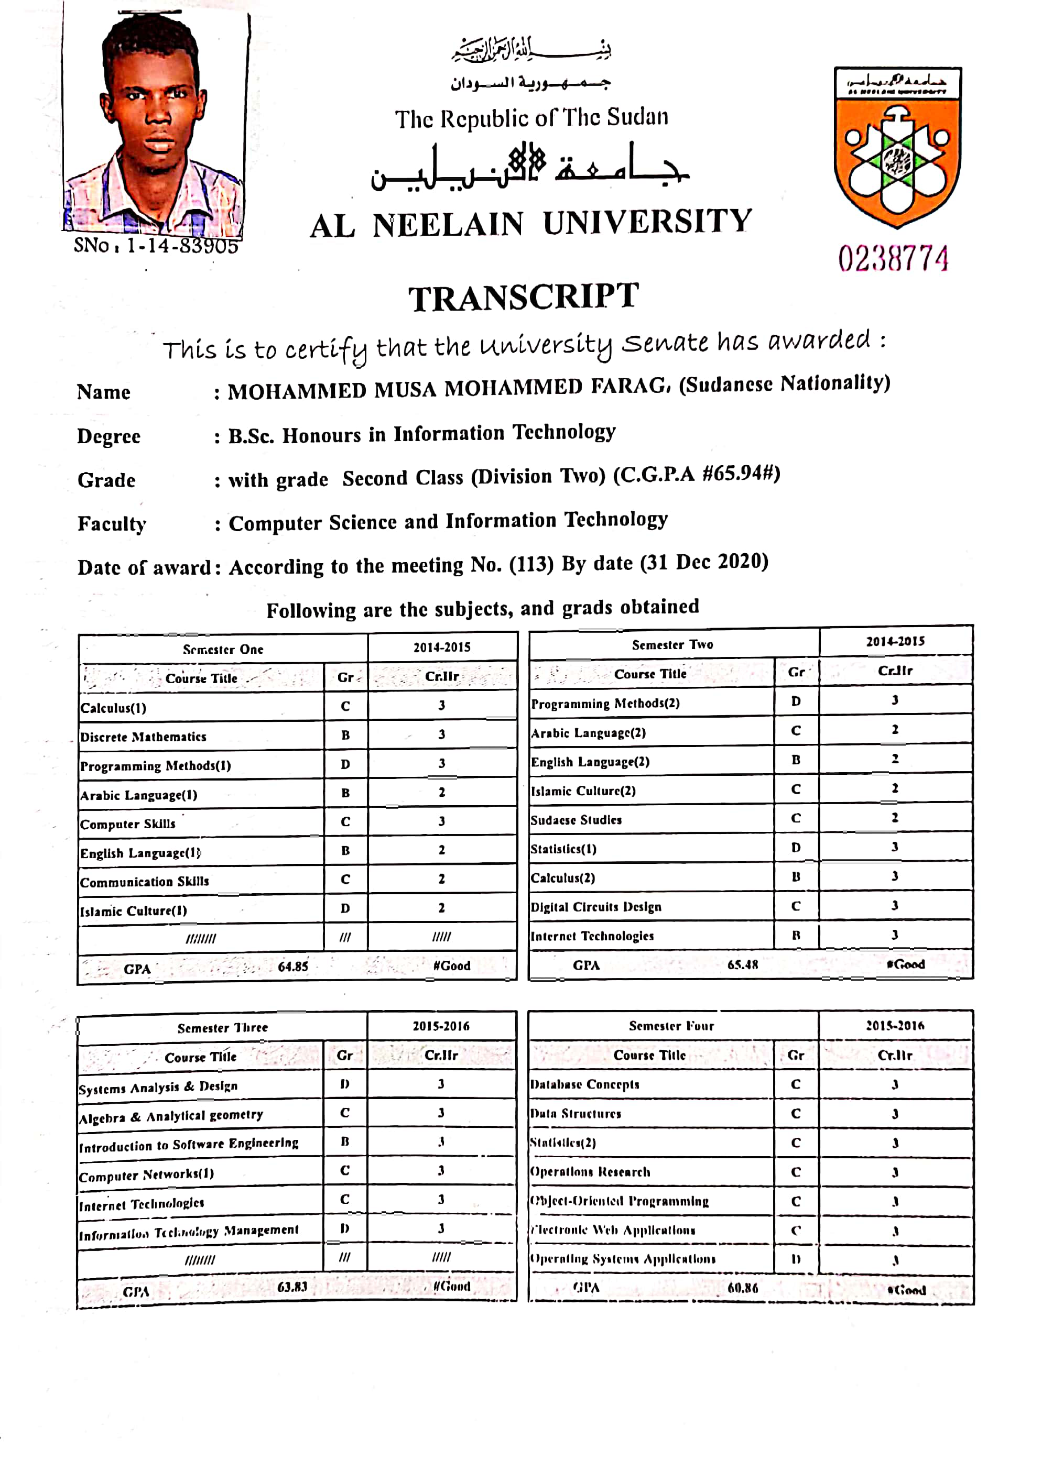

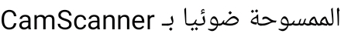

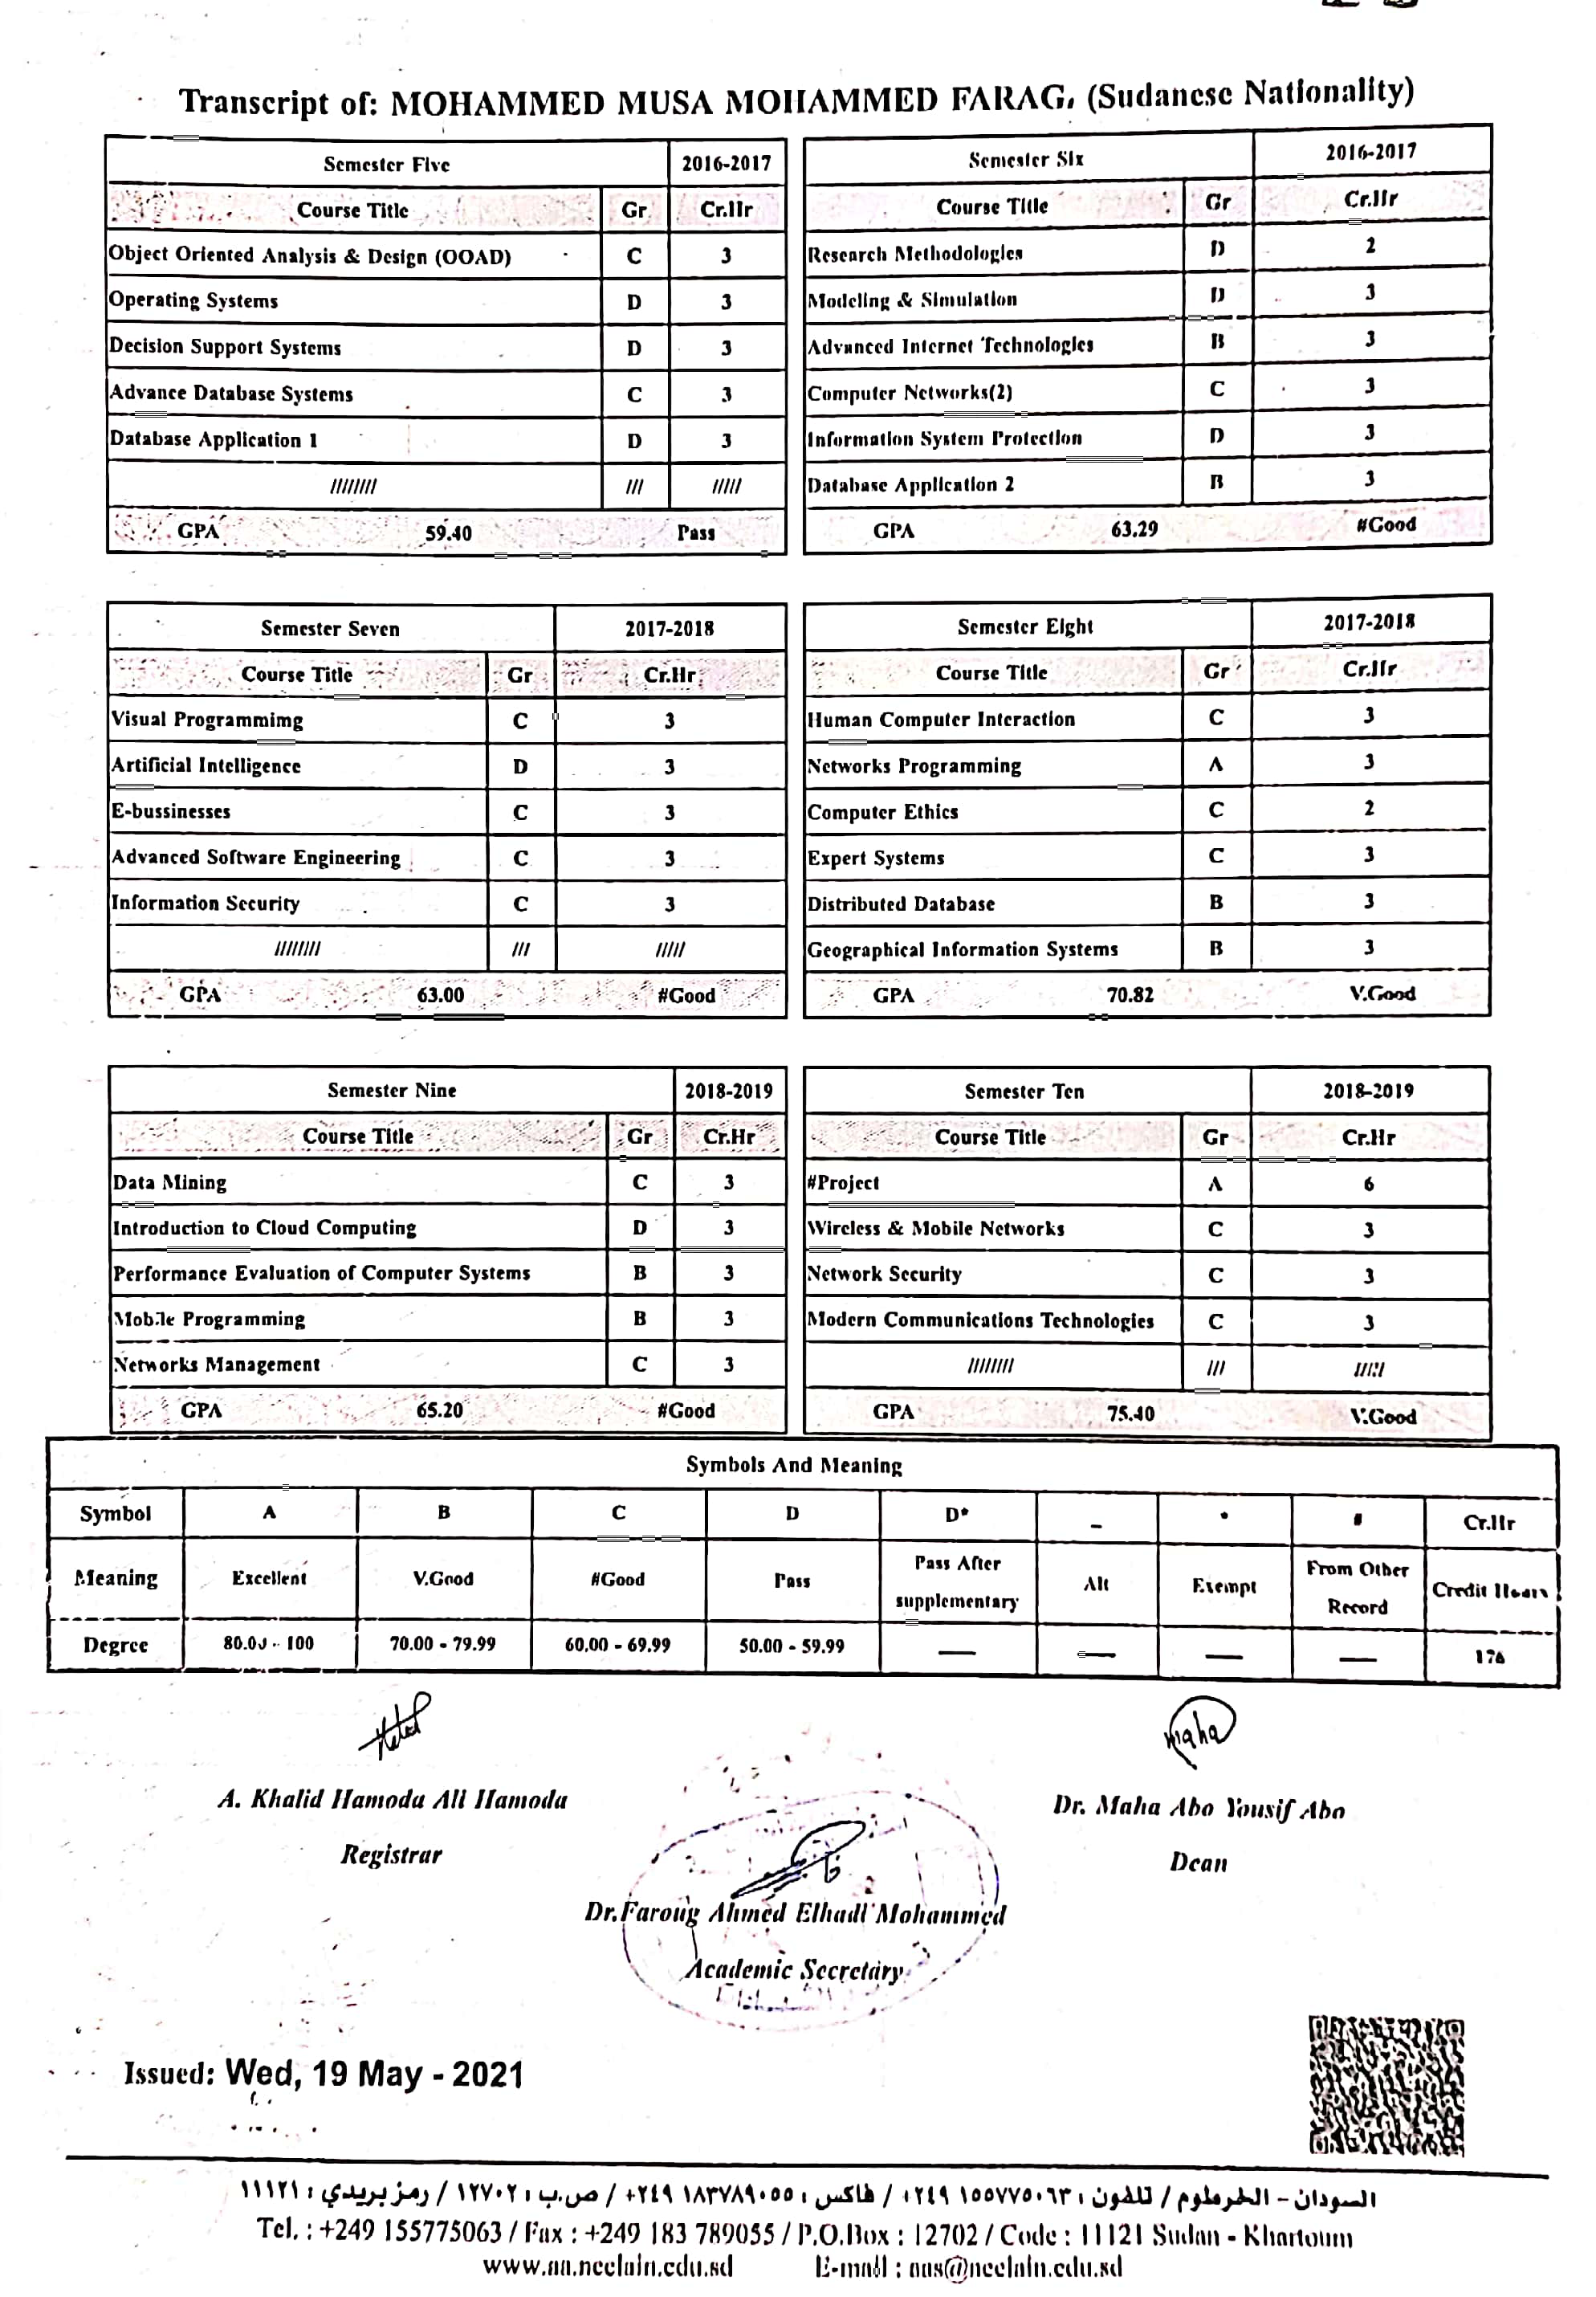



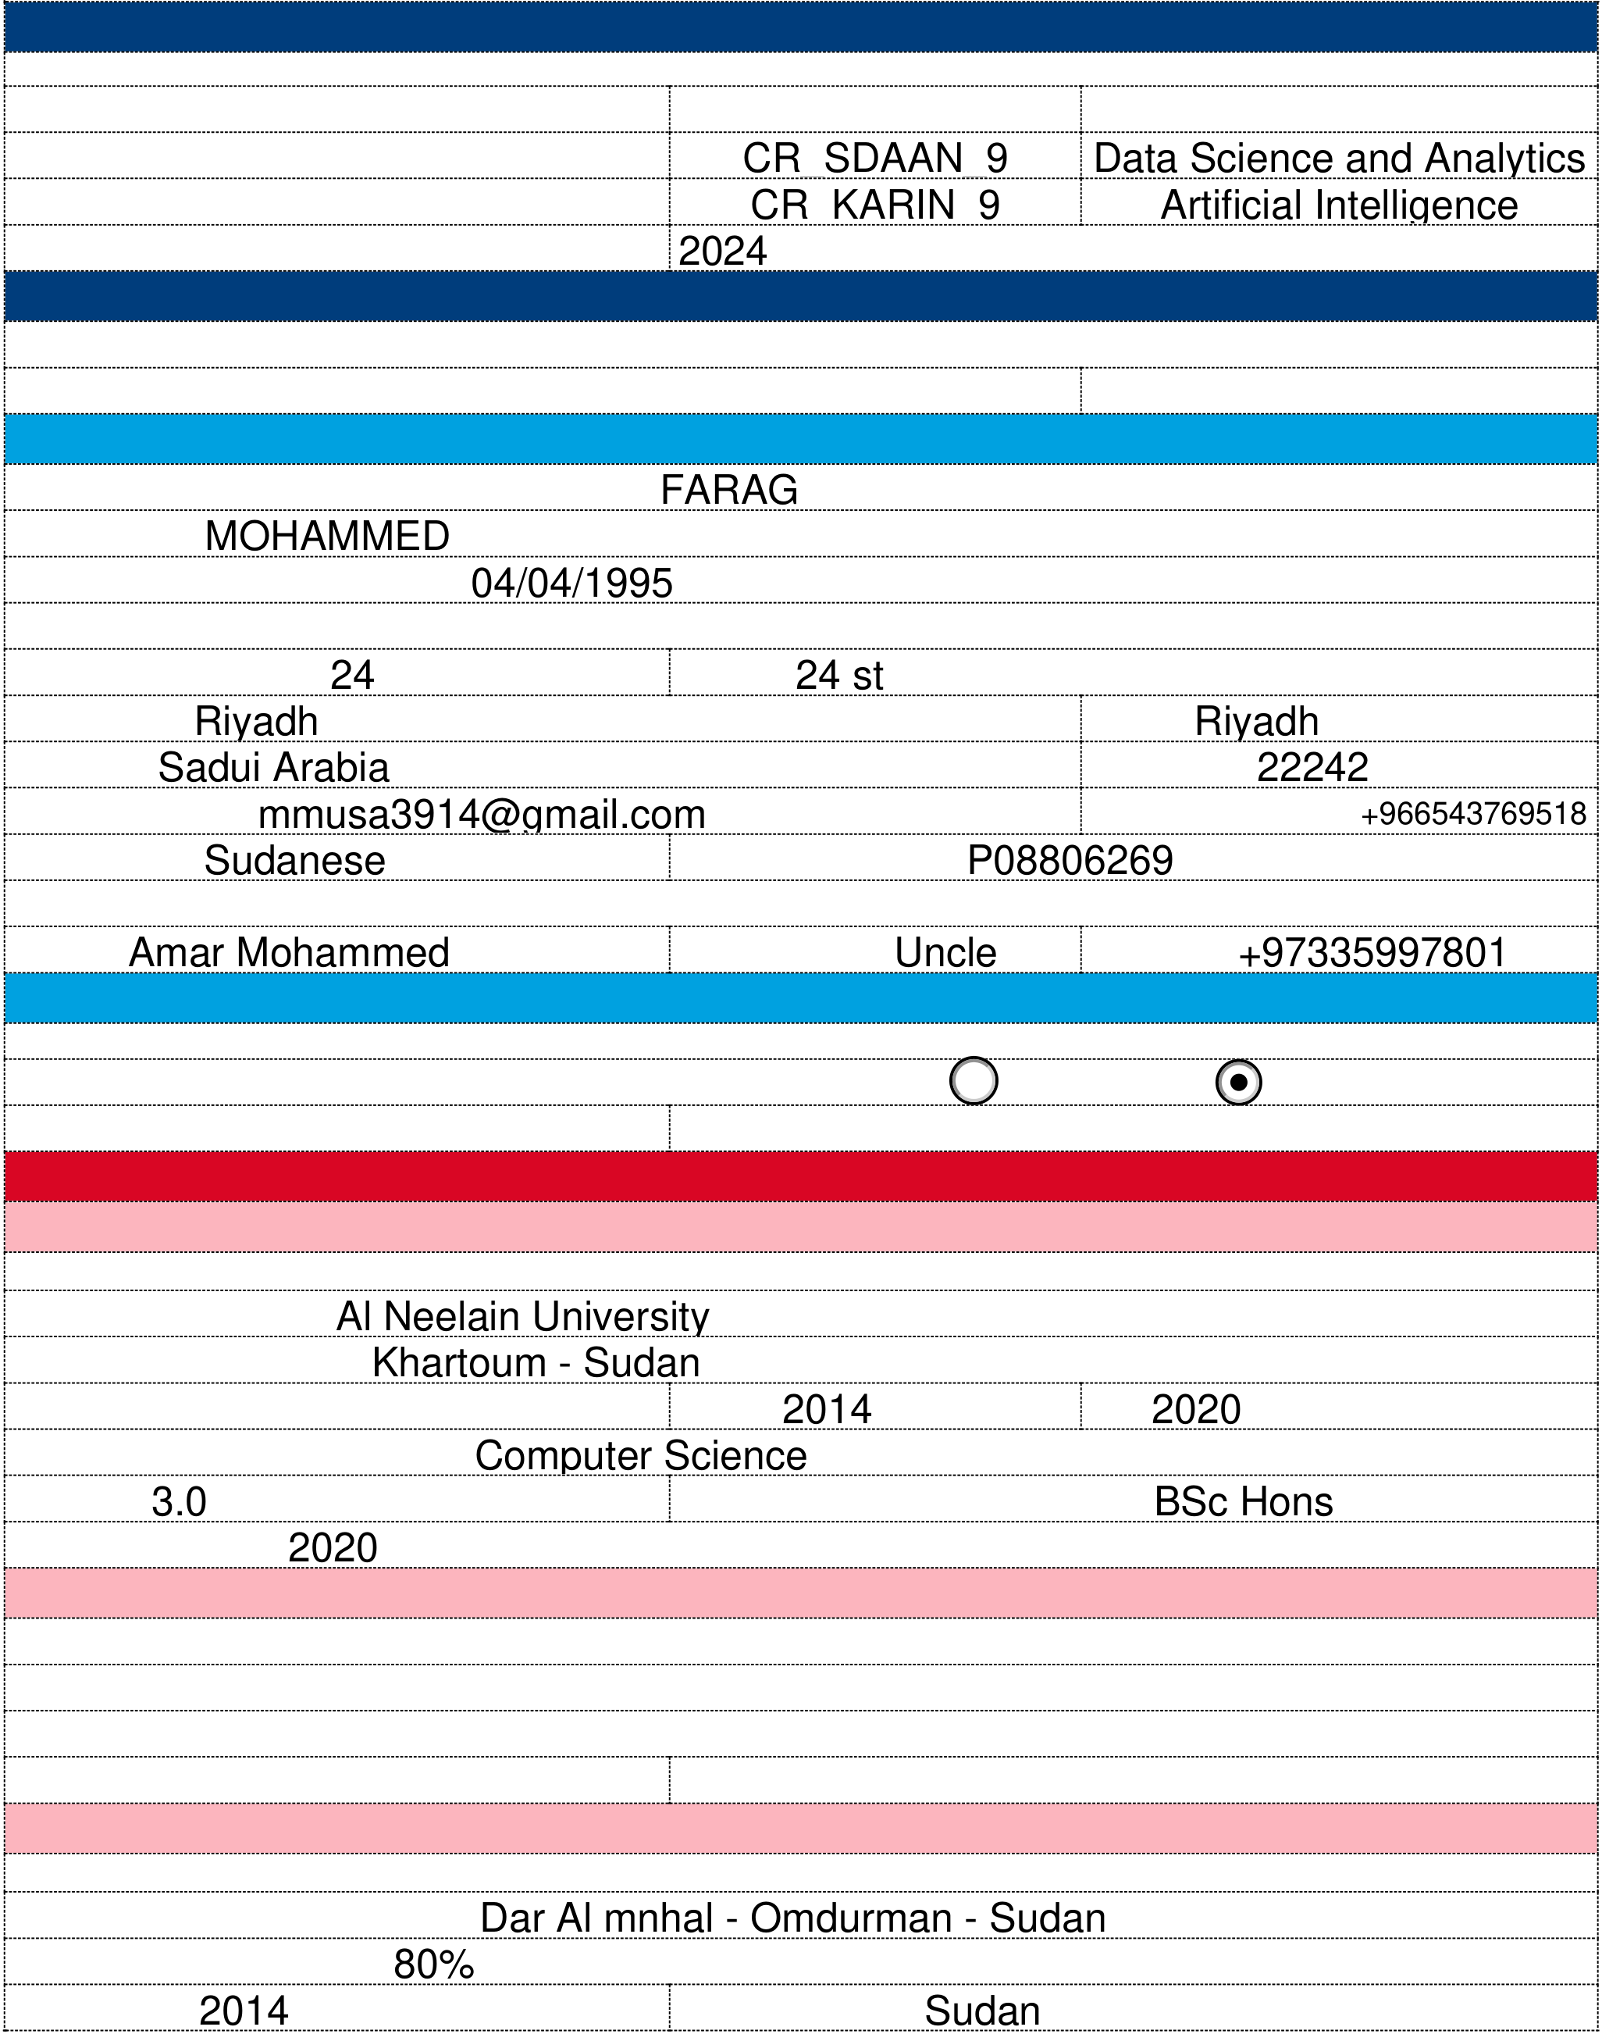

**Non-EU Application Form 2024/25 - Cork Campus Locations**

**Course Choice**

Please use course codes and programme titles as outlined in the MTU Cork prospectus: [www.mtu.ie/courses/cork](http://www.mtu.ie/courses/cork)

|  |  |  |
| --- | --- | --- |
| First Preference: | Course Code | Course Title |
| CR_SDAAN_9 CR_KARIN_9 2024  **Agent Details (if applicable)** | Data Science and Analytics Artificial Intelligence |
| Second Preference: |
| Year of Entry (If undergraduate): |

Agency:

Agent filling form: Email:

**Personal Details**

Surname/Family Name (as on Birth Cert): FARAG

First Name: MOHAMMED

Date of Birth (DD/MM/YYYY): 04/04/1995

*Correspondence Address*

House/Apt number: 24 Street: 24 st

Town/City: Riyadh State: Riyadh

Country: Sadui Arabia Postcode: 22242

Email Address: mmusa3914@gmail.com Contact number: +966543769518

Nationality: Sudanese Passport number: P08806269

*Emergency Contact*

Name: Amar Mohammed Relationship: Uncle Number: +97335997801

**EU Residency**

If you think you are entitled to EU Fees, please check <https://international.cit.ie/am-i-eu-or-non-eu>

Are you currently resident in an EU State? Yes No

If yes, for how long: If yes, Irish immigration Card Stamp card type:

**Education History**

**Third Level (University)**

*If still completing/due to complete exams write pending in exam sections*

Name of Institution: Al Neelain University

Address of Institution: Khartoum - Sudan

Years of Study: From: 2014 To: 2020

Major areas of specialisation: Computer Science

Results: 3.0 Qualification (BSc, BEng, BA etc.): BSc Hons

Graduation Date: 2020

**Foundation Level (If applicable)**

Foundation programme provider:

Level of programme:

Stream (Art, Science and Business):

Results: Graduation Date:

**Second Level (High/Secondary)**

*If still completing/due to complete exams write pending in exam sections*

Name and Address of School: Dar Al mnhal - Omdurman - Sudan

Highest exam achieved: 80%

Exam date: 2014 Exam authority: Sudan

1



|  |  |  |  |  |  |  |  |  |  |  |  |  |  |  |  |  |  |  |
| --- | --- | --- | --- | --- | --- | --- | --- | --- | --- | --- | --- | --- | --- | --- | --- | --- | --- | --- |
| Subjects | | | | | | | Level | | | | | | | Grade/Mark | | | | |
|  | | | | | | |  | | | | | | |  | | | | |
|  | | | | | | |  | | | | | | |  | | | | |
|  | | | | | | |  | | | | | | |  | | | | |
|  | | | | | | |  | | | | | | |  | | | | |
|  | | | | | | |  | | | | | | |  | | | | |
|  | | | | | | |  | | | | | | |  | | | | |
|  | | | | | | |  | | | | | | |  | | | | |
|  | | | | | | |  | | | | | | |  | | | | |
|  | | | | | | | ence from your studies an | | | | | | |  | | | | |
| Please indicate any periods of leave of absence from your studies and reason: | | | | | | | | | | | | | | | | | | |
| **English Language Qualification** | | | | | | | | | | | | | | | | | | |
| First Language/Mother tongue: | | | | | | | | | | | | | | | | | | |
| Current English Exam: | | | | | | | | | | | | | | | | | | |
| Overall Score: | | | | | | | | | | | | | | Date: | | | | |
| **Professional/Industrial Experience** | | | | | | | | | | | | | | | | | | |
| Name of current/recent employer: | | | | | | | | | | | | | | | | | | |
| Address: | | | | | | | | | | | | | | | | | | |
| Date of Employment: | | | | | | | From: | | | | | | | To: | | | | |
| Nature of work: | | | | | | | | | | | | | | | | | | |
| **Where did you hear about MTU** | | | | | | | | | | | | | | | | | | |
| Education Fair | |  | |  | | | Agent | |  | |  | | | MTU Open Day |  |  | | |
| MTU Representative | | | | |  |  | Web |  | |  | | | | Guidance Counsellor | | |  |  |
| Social Media |  | |  | | | |  |  |  | p |  |  |  |  |  |  |  |  |
| News | p | a | p | er/Radio |  |  | Word of Mouth |  |  |  |  |
| Other (please specify): | | | | | | | | | | | | | | | | | | |
| **Declarations** | | | | | | | | | | | | | | | | | | |
| If you have a disability, learning difference or health condition and need support around this when attending MTU for lectures/exams, please contact the Disability Support Service at [dssCork@mtu.ie](mailto:dssCork@mtu.ie) or check [www.mycit.ie/dss.](http://www.mycit.ie/dss) You will need to do this well in advance of your arrival. Please note that MTU DSS suppo[rts may differ from](http://www.mycit.ie/dss) those you receive in your home institution. You may need to make a financial plan including additional disability related costs. | | | | | | | | | | | | | | | | | | |
| I affirm that the particulars given in relation to this application are in all respects true and I agree to be bound by the academic regulations of the University. I confirm that all copies of transcripts and other official documents are authentic. | | | | | | | | | | | | | | | | | | |
| All information gathered by the University will be used only for the purposes registered under the general Data Protection Regulation 2018. Copies of the University’s Data Protection Policy may be obtained from https://www.mtu.ie/policies | | | | | | | | | | | | | | | | | | |
| **Signature:** Mohammed | | | | | | | | | | | | | | | | | | |
| **Date:** 20/01/2024 | | | | | | | | | | | | | | | | | | |
| Please check you have accurately completing all questions. Incomplete applications will result in delay. | | | | | | | | | | | | | | | | | | |
| Please refer to our website for full list of documents <https://international.cit.ie/make-an-application> | | | | | | | | | | | | | | | | | | |
| **All full applications to be sent as 1PDF (documents merged together) to [noneu.applicationscork@mtu.ie](mailto:noneu.applicationscork@mtu.ie)** | | | | | | | | | | | | | | | | | | |

2